**PARTICIPANT DETAILS**

**NAME :** SUSMITH A J

**THEME :** E-COMMERCE

**EMAIL ID :** susmith508@gmail.com

**B.TECH CSE (3rd Year)**

GOVERNMENT COLLEGE OF ENGINEERING KANNUR

**INDEX**

**1 INTRODUCTION**

1.1 Overview

1.2 Purpose

**2 LITERATURE SURVEY**

2.1 Existing problem

2.2 Proposed solution

**3 THEORITICAL ANALYSIS**

3.1 Block diagram

3.2 Hardware / Software designing

**4 EXPERIMENTAL INVESTIGATIONS**

**5 FLOWCHART**

**6 RESULT**

**7 ADVANTAGES & DISADVANTAGES**

**8 APPLICATIONS**

**9 CONCLUSION**

**10 FUTURE SCOPE**

**11 BIBILOGRAPHY**

APPENDIX

A. Source code

**1. INTRODUCTION**

**1.1 Overview**

In this document we discussing about multi-Vendor Marketplace Your Baazaar. This eCommerce website will be helpfull for local shop or other store who do not have their own online marketplace.

Your Baazaar Multi-Vendor Marketplace have two perspective:

* **From merchant (formally admin) shop**

Your Baazaar Multi-Vendor Marketplace adds to the inventory of products on the merchant's site by adding vendor's products. And more vendors will add their products, the inventory of the site will also increase.

* **From vendor**

Using Your Baazaar Multi-Vendor Marketplace vendor can sell and promote their products online from the merchany's (admin) shop.

**1.2 Purpose**

Purpose of Your Baazaar is to fulfill the requirement of supply chain management without breaking the cash-flow. In simple words, it is a place where buying and selling occurs.

**2. LITERATURE SURVEY**

**2.1 Existing Problem**

eCommerce websites are hiking their value in this era and will be in future too. Number of eCommerce website are also increases. But this affects small shop owners. So their profits are no longer gets increases than they did before. So the only way to solve this problem is host their online webstore or sell products to through other's website.

**2.2 Proposed Solution**

Your Baazaar Has solved this problem by opening Multi-Vendor Marketplace for thhe shop owners who do not have online webstore to sell their products. We Know modt of the shop owners does not know how to set this webstore. So we made simple and easy setup to start their store using Dokan plugin. Dokan plugin gives get dashboard with easy maintance and also anyone can sell products through this marketplace easily.

**3. THEORITICAL ANALYSIS**

**3.1 Block Diagram**

Block diagram for account management for vendors.

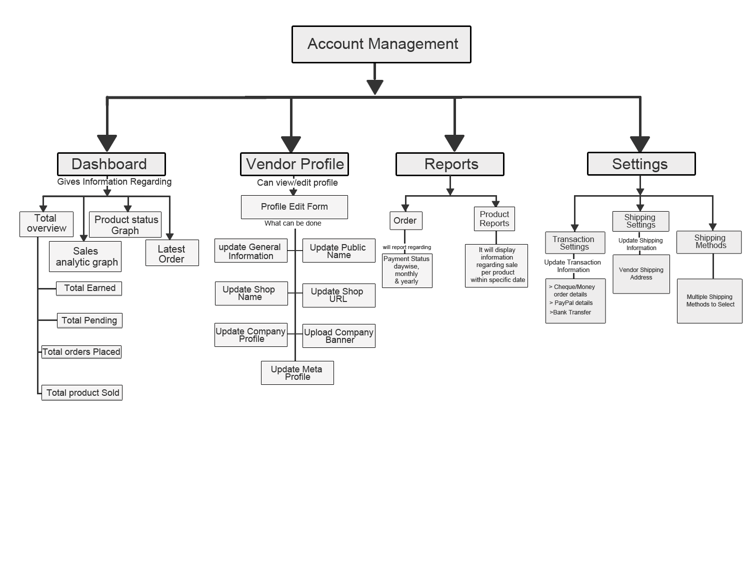

**3.2 Hardware/Software Designing**

There is no any special requirements needed. Vendors and users can use their devices (Smartphones, Laptops or Tablets) to do their needs. It is responsive website so no issues for customers to use.

**4. EXPERIMENTAL INVESTIGATIONS**

I found many useful plugins to make website better but they costs too much. So did every this 100% free products to make this website. To make this kind of website is not easy but I can make this lot easier these plugins;

* Elementor theme editor ( for Front-end Design)
* Woocommerce (eCommerce Setup)
* Dokan (Multi-Vendor Setup)
* Mailchimp and WP forms (Email Marketing)
* Yoast SEO (For rank in google search)

These plugins made more easier to build this eCommerce website.

**5. FLOWCHART**

**Vendor Registration Process**

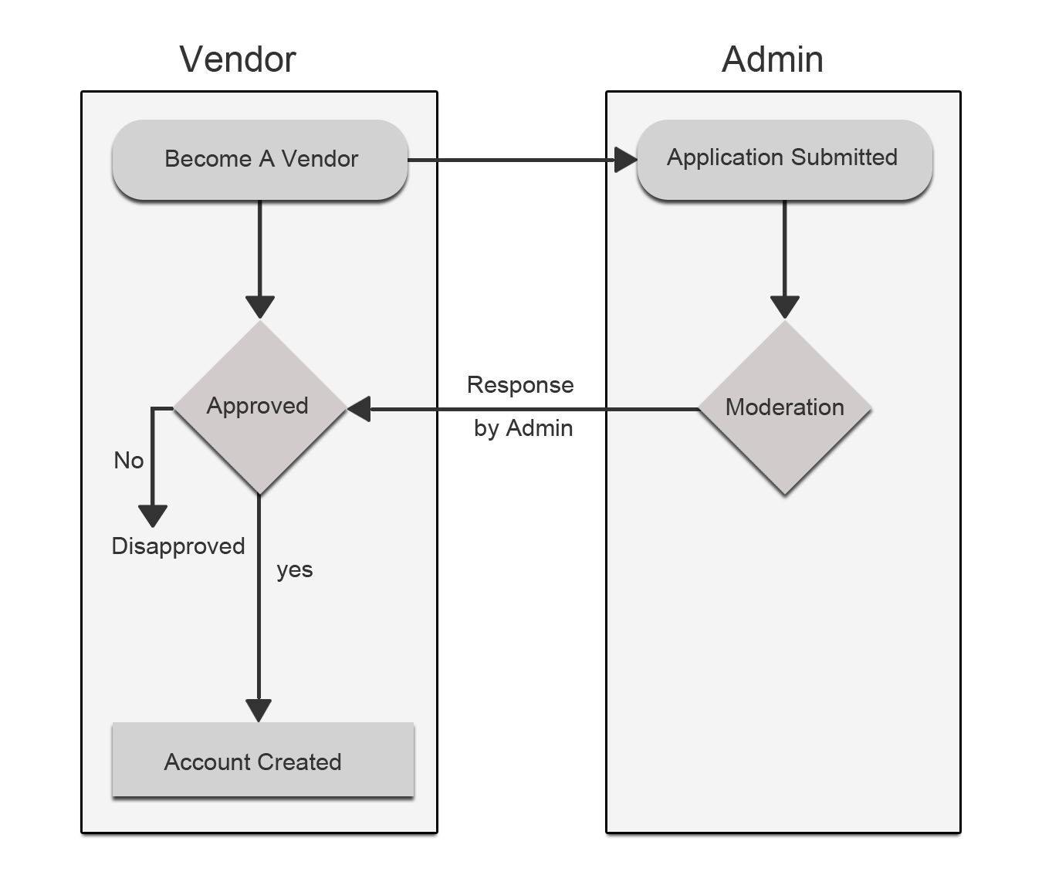

**Catalog Management**

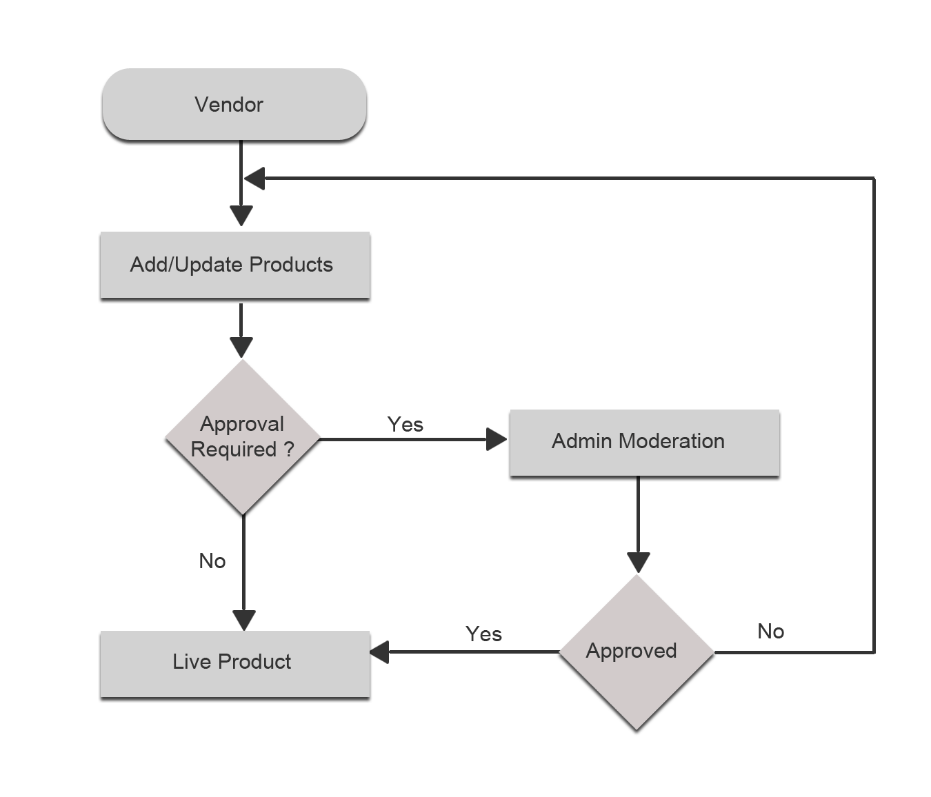

**Multi-Vendor Marketplace Order Lifecycle**

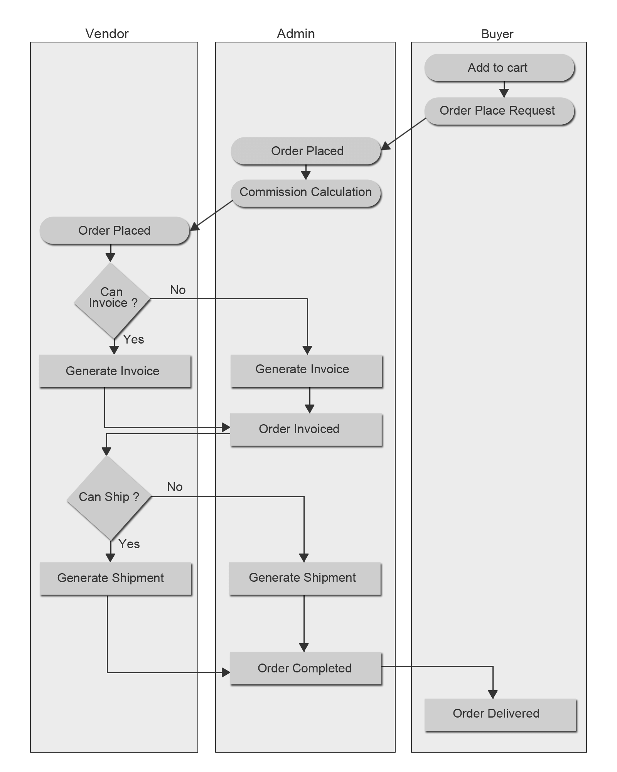

**Transcation LifeCycle**

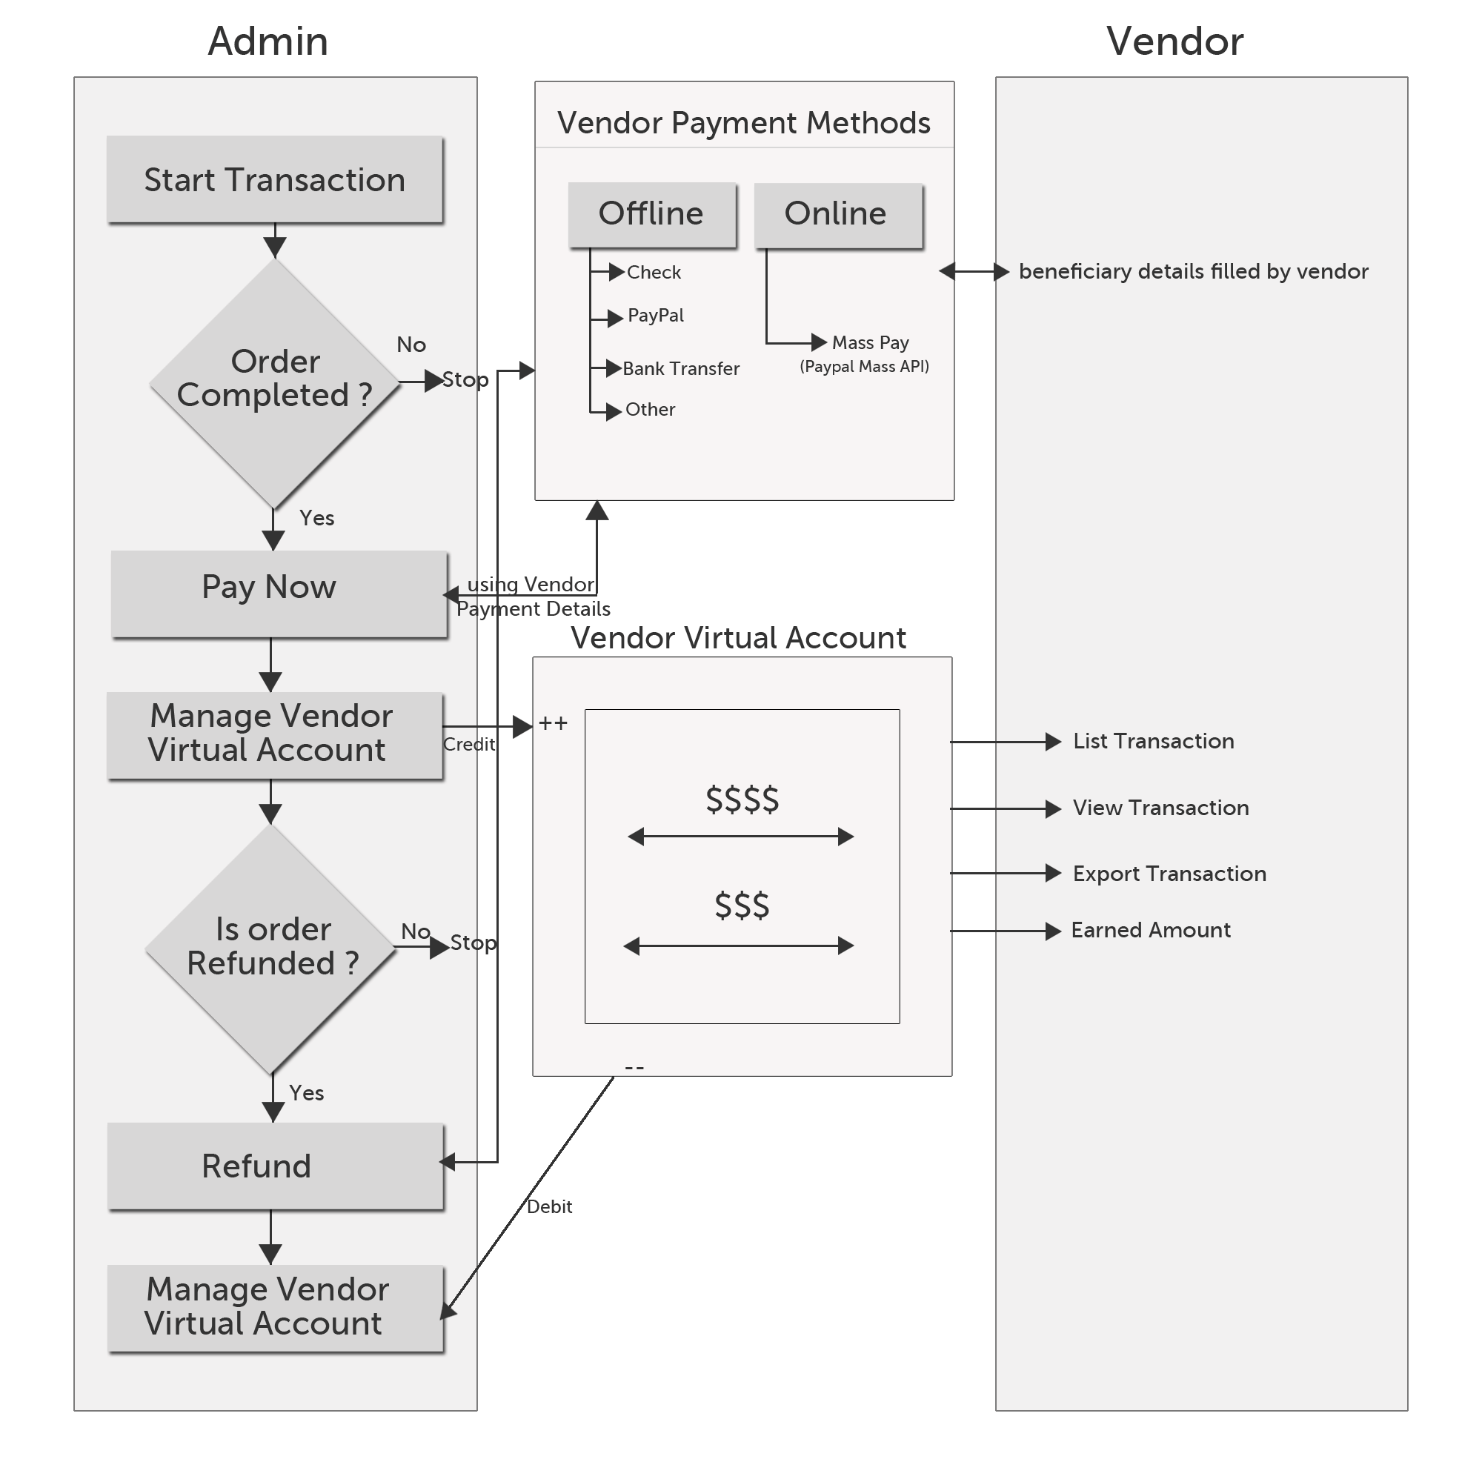

**6. RESULT**

Home Pages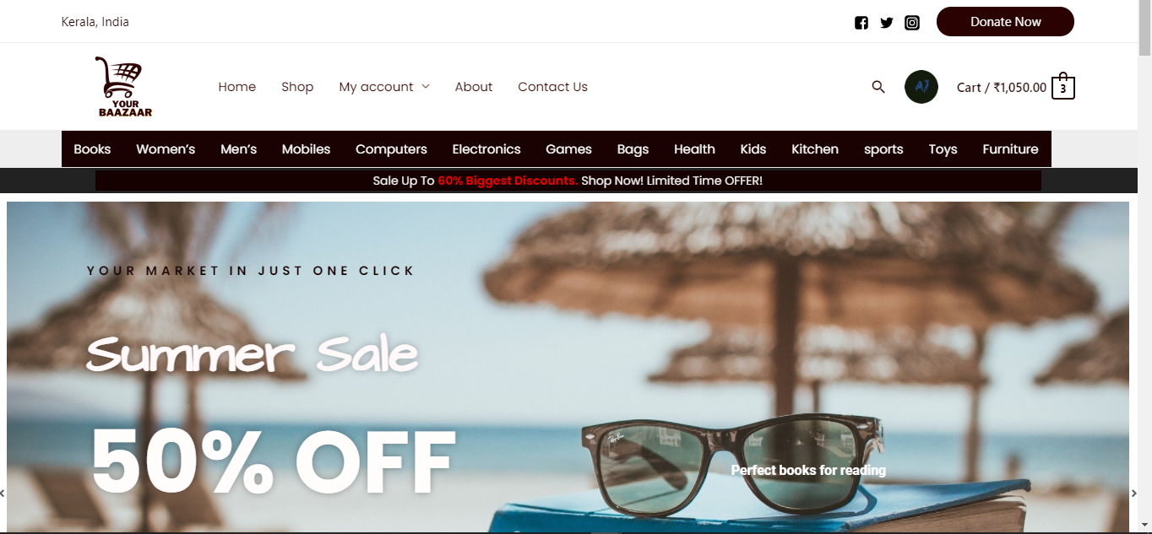

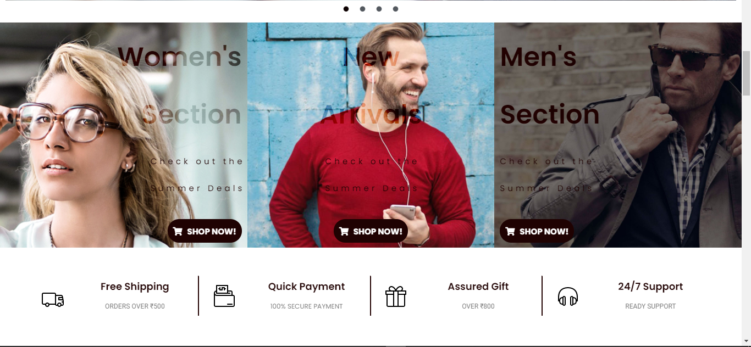

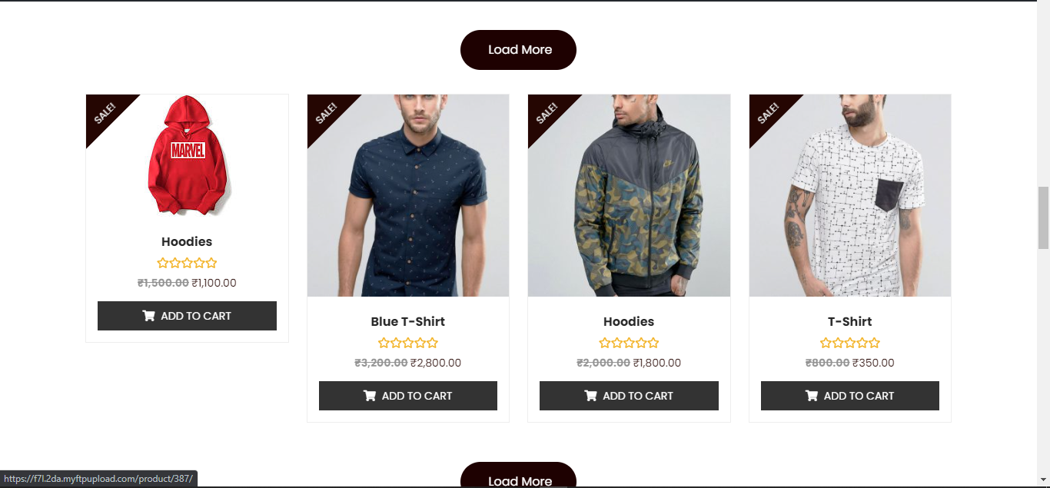

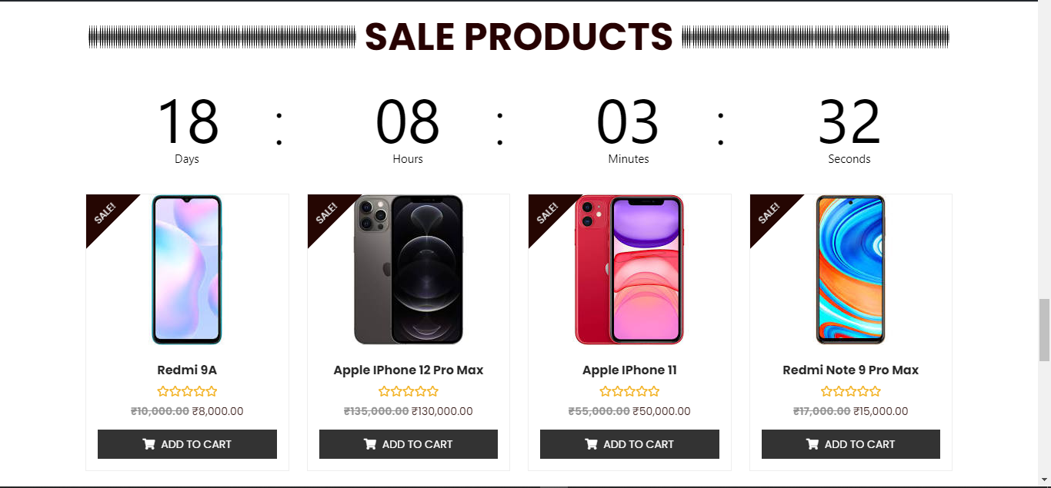

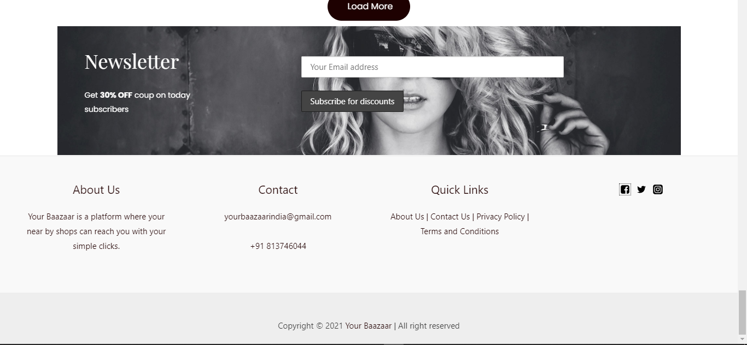

Shop Page

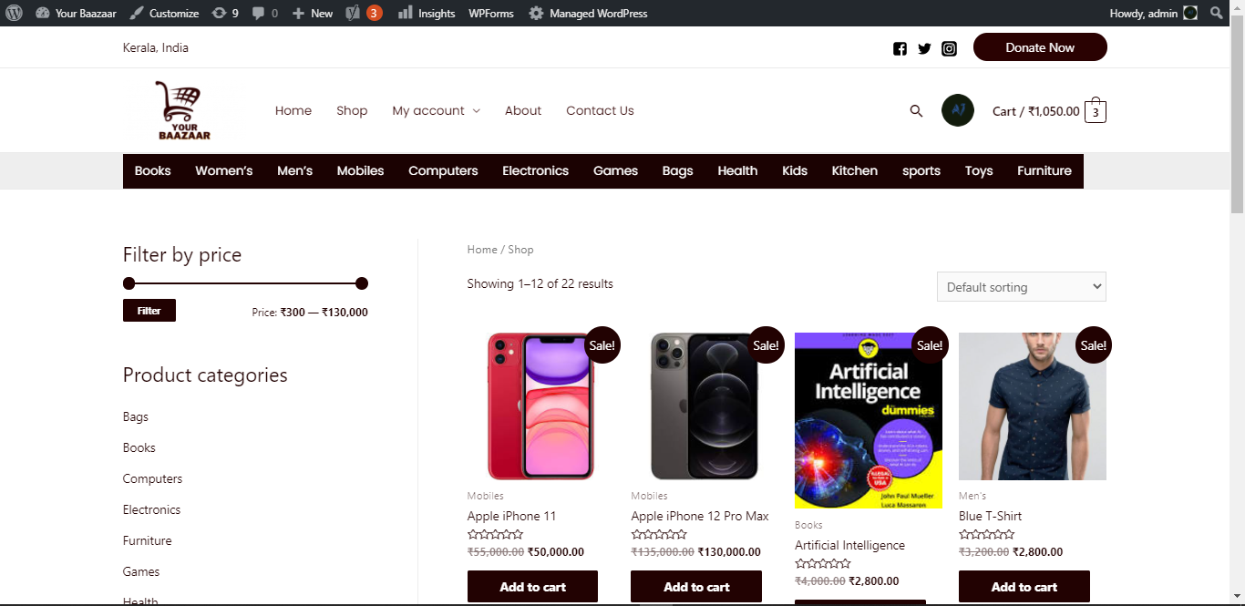

My Account Page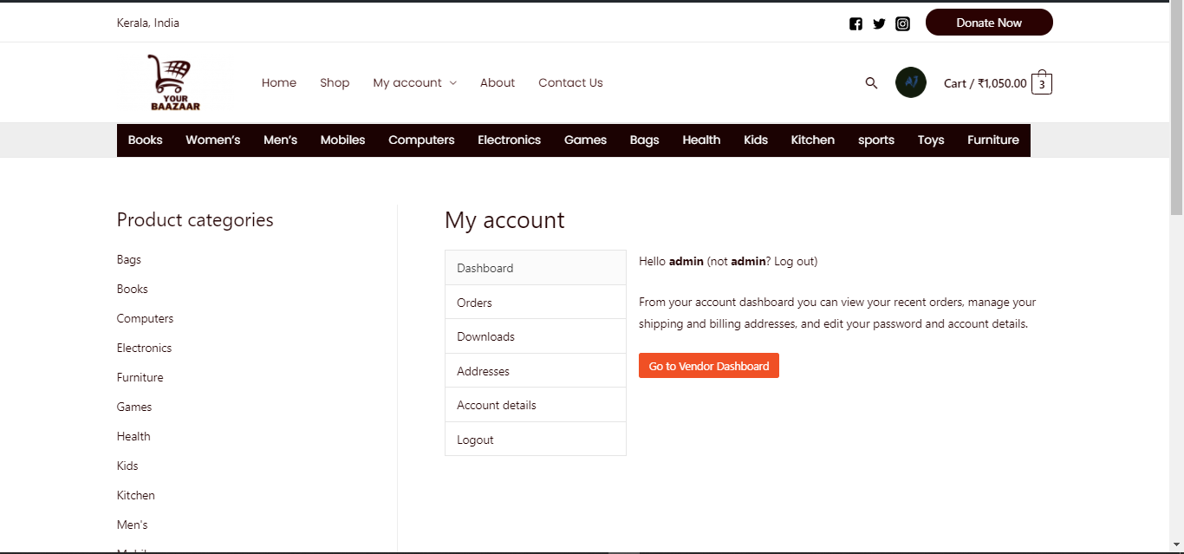

Checkout Page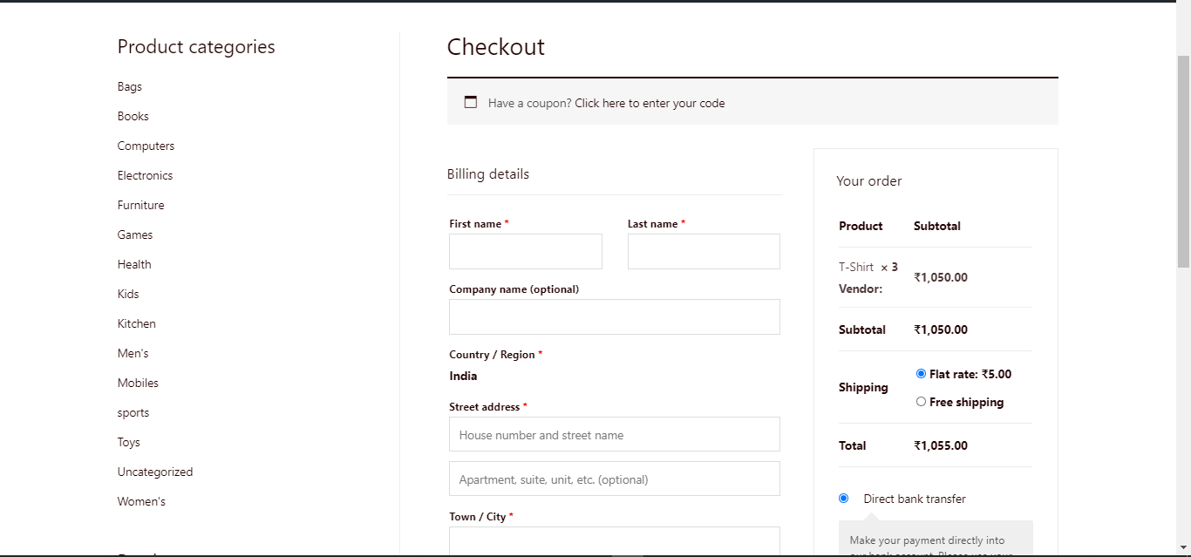

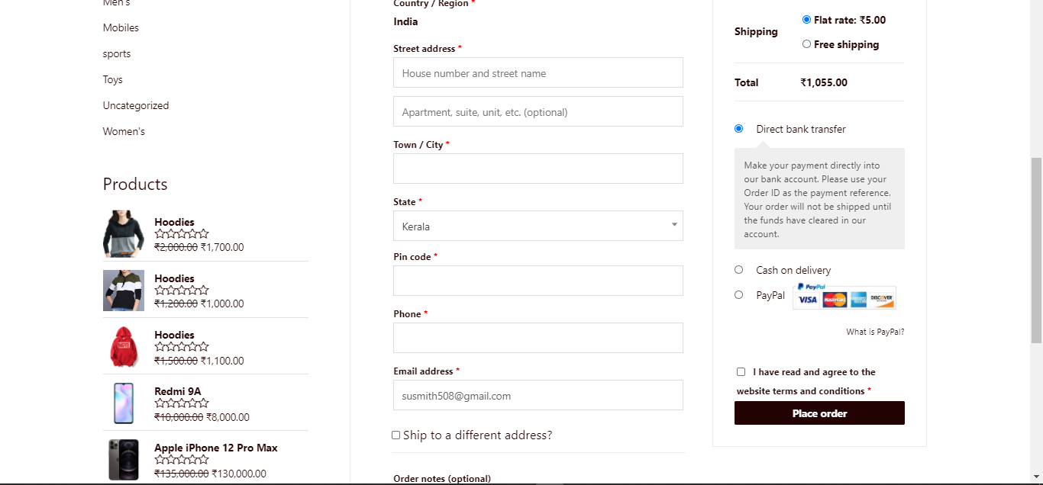

Cart Page

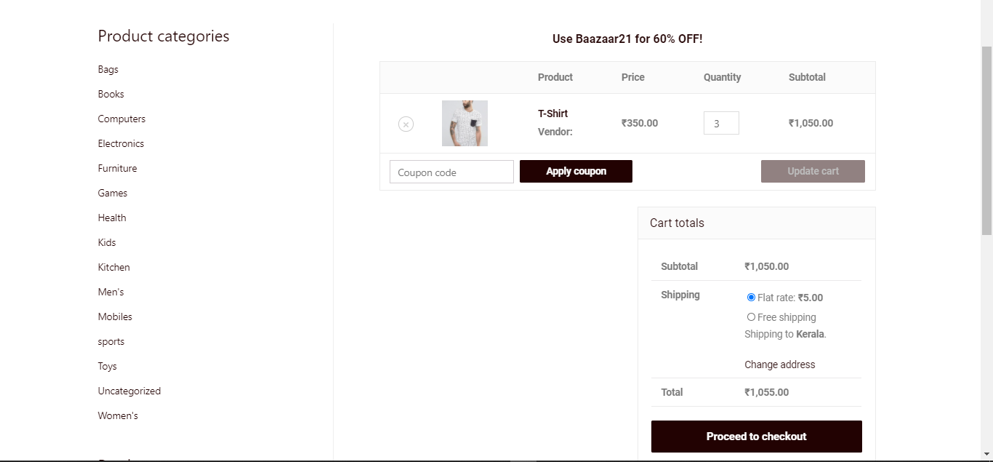

About Page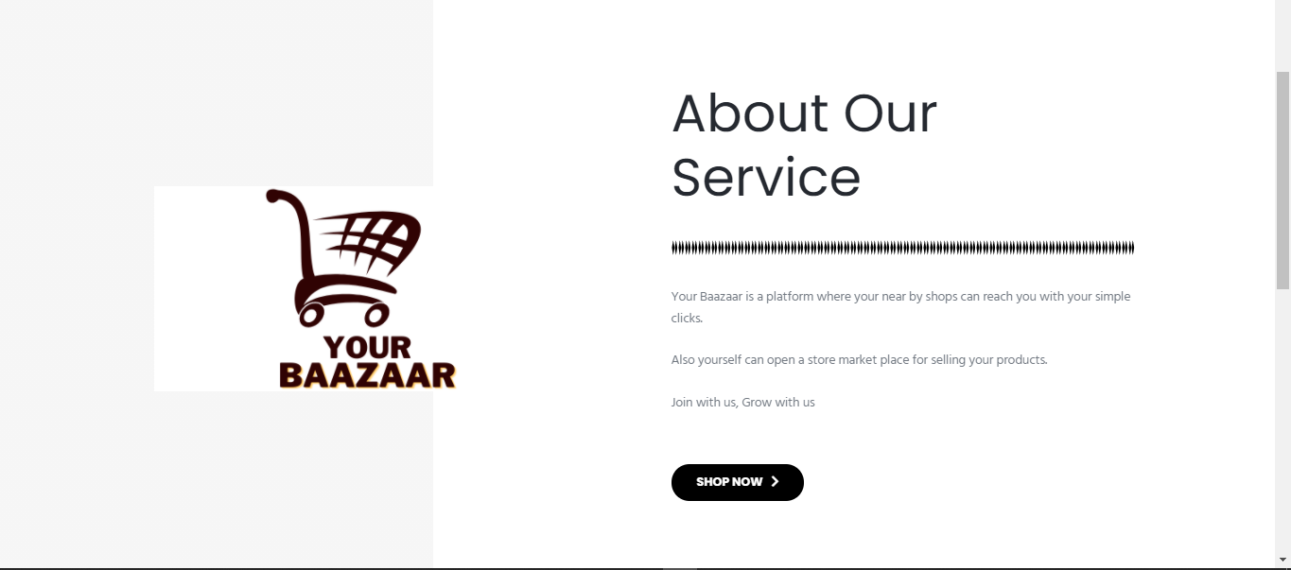

Contact Us Page

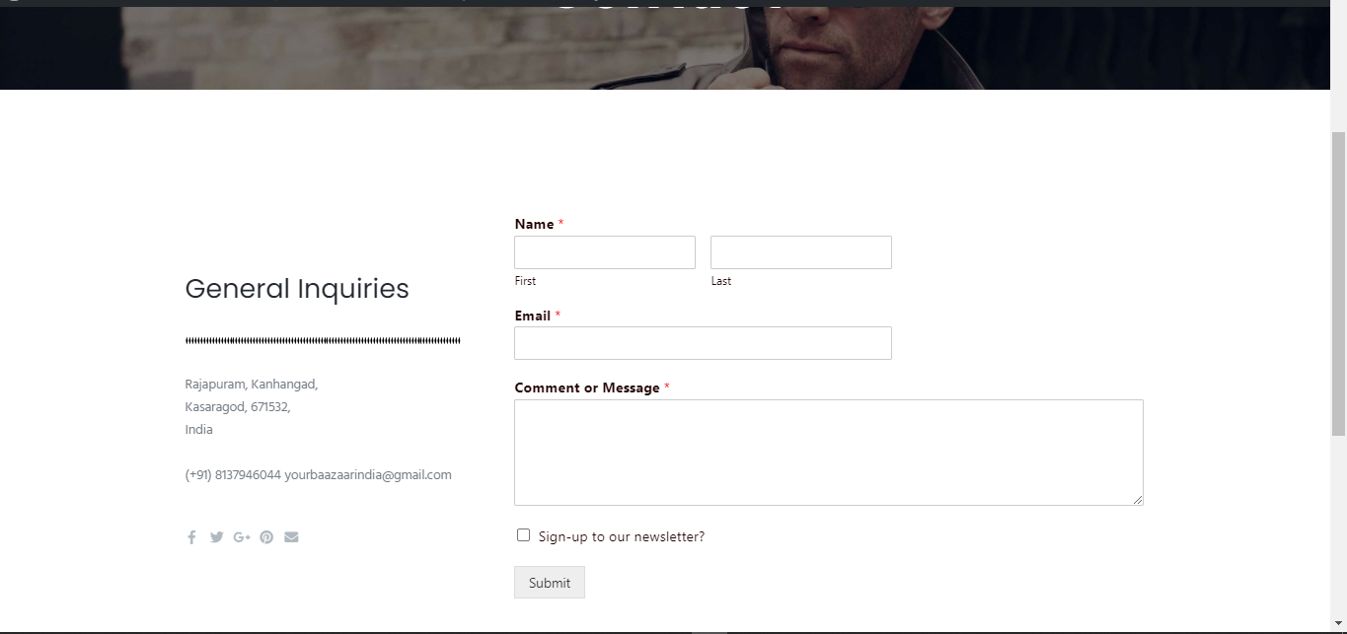

Vendor's Dashboard

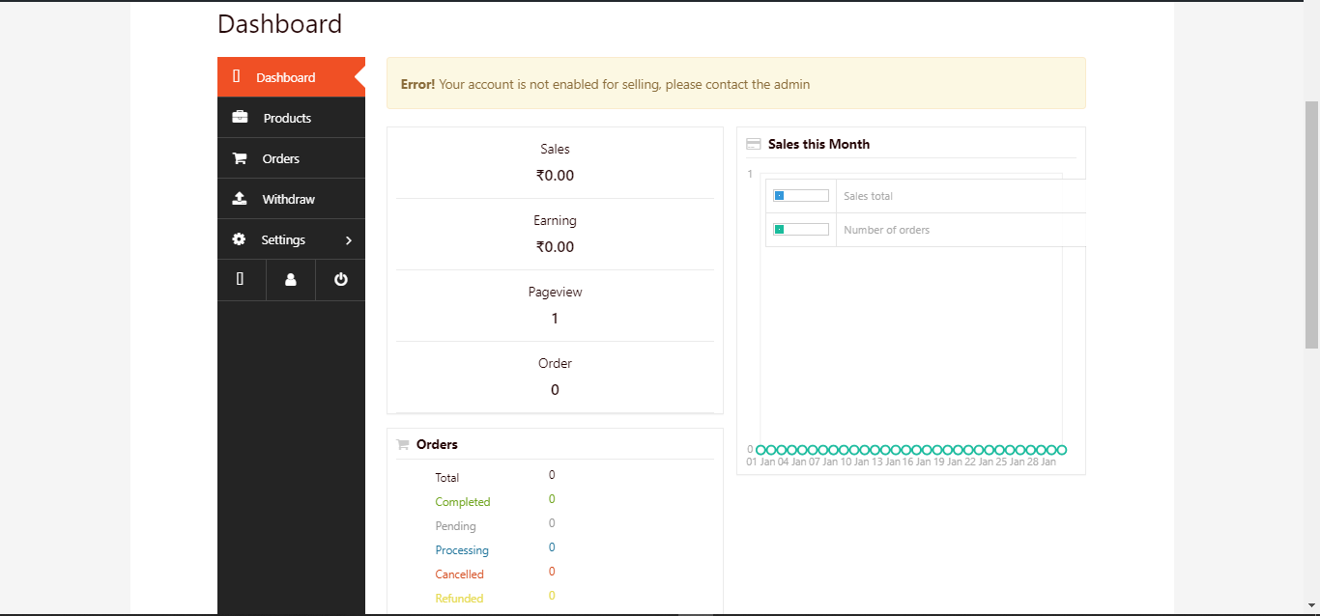

Vendor's Product Orders Page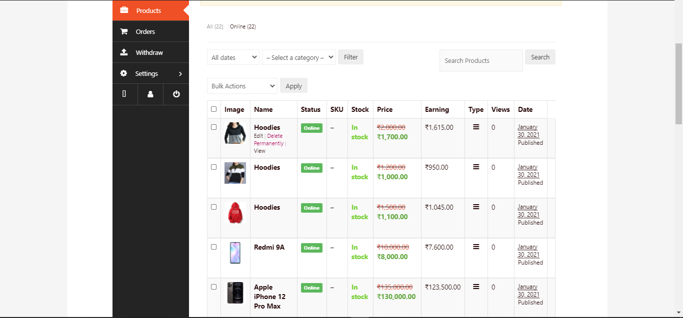

**7. ADVANTAGES & DISADVANTAGES**

Multi-Vendor marketplace websites has transformed into efficient business model and enableed businesses who don't have a product or service to sell to get into the eCommerce. Here Your Baazaar involves 3 parties namely buyers, sellers and facilitator (admin) of the marketplace platform with rach having their own advantages and disadvantages.

* **Seller**

**Advantages**

1. Wide range of customers

2. Equal Market Opportunity

3. Access to new markets

4. Easy of Marketing

5. Hassle free shipping

**Disadvantages**

1. Commission fee to the owner of the marketplace

2. Control over the selling cost

* **Consumer**

**Advantages**

1. Extended range of products

2. Exclusive deals

3. Ease of finding alternate products

**Disadvantages**

1. Lack of personlized products

2. Subjection to manipulation

* **Owner**

**Advantages**

1. Easy to scale

2. No need to maintain an active inventory

3. Commision based business model

4. Cost effective

**Disadvantages**

1. Hassles of shipping and return

2. Legal and tax compliance's

**8. APPLICATIONS**

When comparing with local shops to Your Baazaar multi-vendor website these are applications;

* Mutli-Vendor platform
* Online Shopping Cart
* Instant offer Notifications
* Common Marketplace Storefront ( so easy to find better offers and products qaulity)
* Bulk Product Import/Export
* High Competition
* Digital Proof of Delivey (Great Customer Care)
* Marketing Support

**9. CONCLUSION**

Your Baazaar is overweighted by the advantages involved thus empowering all three parties (admin, seller and cosumer) involves in a win-win situation. The fact that there is a huge surge in the usage of free multi-vendor marketplace is proof that this is a successful model. The future of it also looks confident with more businesses rather than going for an individualeCommerce platform for their business.

**10. FUTURE SCOPE**

Your Baazaar is a Multi-Vendor platform where the products from multiple independent vendors appear in the common product catalog on the merchant's (formally admin) website and the visitors can shop for them at a single web store with the products supplied by the registered vendors.

Currently we do not have a RMA(Return Merchandise Authorization). So we set this RMA request process soon as possible.

**11. BIBILOGRAPHY**

I made whole website using the video tutorials provided by Godaddy Academy:

1. Working With Wordpress : https://godaddyacademy.com/app/courses/working-with-wordpress/

2. Understanding Website : https://godaddyacademy.com/app/courses/understanding-websites/

I refered this youtube video to fix multivendor setup using Dokan plugin;

<https://www.youtube.com/watch?v=aX3-bjO8ER8>

**APPENDIX**

Plugins Used for completion of the Your Baazaar website;

1. Astra Theme

2. Mailchimp

3. Elementor ElementsKit Lite

4. Dokan

5. WP Forms

6. Updarafts

7. WooCommerce

8. Yoast SEO

9. Kadence woocommerce email designer

10. Essential Addons for Elementor

11. Premium Addons for Elementor